**MIT School of Engineering**

**Department of Computer Science and Engineering**

**Project Synopsis**

**Group ID: 6**

**Project Title: Radio Test Analysis**

**Group Members:**

|  |  |  |  |  |
| --- | --- | --- | --- | --- |
| **Enrollment Number** | **Roll No.** | **Name of student** | **Email Id** | **Contact Number** |
| **MITU21BTCS0177** | **2213721** | **Darsh Thakur** | **thakurdarsh21@gmail.com** | **7666248123** |
| **MITU21BTCS0198** | **2213717** | **Divyansh Shukla** | **Divyansh51004@gmail.com** | **9009958172** |
|  |  |  |  |  |
|  |  |  |  |  |

**Problem Statement:**

The current process for analyzing radiology test results is time-consuming and error-prone, leading to delays in diagnosis and potential misinterpretations of medical images. There is a need for an efficient and accurate system that can assist radiologists in interpreting radiology test results, improving the speed and reliability of diagnoses while reducing the burden on healthcare professionals

**Abstract:**

Radiology test analysis is a critical component of modern healthcare, enabling the timely and accurate diagnosis of various medical conditions. However, the reliance on manual interpretation of medical images can be time-consuming, subject to interobserver variability, and sometimes prone to errors, potentially causing delays in patient care. This abstract emphasizes the importance of developing integrated hardware and software solutions for radiology test analysis. These solutions, driven by cutting-edge technologies such as artificial intelligence and machine learning, aim to improve the accuracy, efficiency, and speed of diagnoses while supporting healthcare professionals in their decision-making processes. Additionally, it highlights the need for a seamless synergy between advanced hardware and sophisticated software to revolutionize radiology test analysis, thereby advancing patient care and medical diagnostics. This abstract underscores the necessity for ongoing research and development efforts to harness the full potential of technology in this field.

**Proposed System (Block Diagram):**

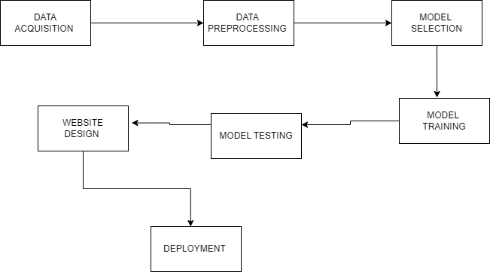

**Conclusion:**

In conclusion, radiology test analysis is a cornerstone of modern healthcare, enabling the prompt and accurate diagnosis of a wide range of medical conditions. Over the years, significant advancements in hardware and software technologies have revolutionized the field, offering a promising future for improved patient care.The integration of advanced hardware, such as high-resolution imaging devices and efficient data acquisition systems, has enhanced the quality and precision of medical images. Meanwhile, sophisticated software solutions, including artificial intelligence and machine learning algorithms, have expedited the interpretation of these images and reduced the potential for human error.The ongoing synergy between hardware and software in radiology test analysis has the potential to transform the way we diagnose and treat patients. It not only improves diagnostic accuracy but also reduces the burden on healthcare professionals, allowing them to focus on more complex and patient-centric aspects of care.As we look to the future, it is imperative that research and development efforts continue to evolve, ensuring that hardware and software solutions in radiology remain at the forefront of innovation. This will ultimately benefit both healthcare providers and patients, by providing faster, more accurate diagnoses, and contributing to improved patient outcomes. Radiology test analysis is poised to continue making a significant impact on the practice of medicine, shaping the landscape of healthcare for years to come.

**References:**

* [**https://www.nature.com/articles/s41746-022-00592-y**](https://www.nature.com/articles/s41746-022-00592-y)
* [**https://pubmed.ncbi.nlm.nih.gov**](https://pubmed.ncbi.nlm.nih.gov/)
* [**https://scholar.google.com**](https://scholar.google.com/)
* [**https://www.sciencedirect.com/topics/medicine-and-dentistry/image-analysis-medical-imaging**](https://www.sciencedirect.com/topics/medicine-and-dentistry/image-analysis-medical-imaging)